The Reliability of Voting Mechanisms
Daniel Babara, Hector Garcia-Molina
IEEE TRANSACTIONS ON COMPUTERS, VOL. C-36, NO. 10, OCTOBER 1987, pp. 1197-1208
Abstract
In this paper we address the problem of selecting vote assignments in order to maximize the probability that the critical operations can be performed at a given time by some group of nodes. We suggest simple heuristics to assign votes, and show that they give good results in most cases.
- Introduction
- The Choices
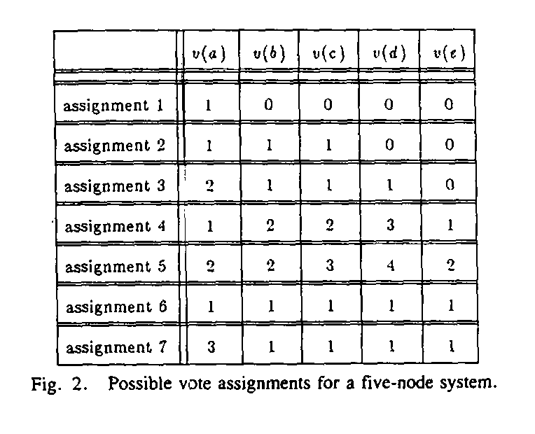
- Uniform assignment
Assignment 6
- Singleton assignment
Assignment 1
- Nonuniform assignment
Others
- The Assignment of Votes
- Arbitrary Graphs
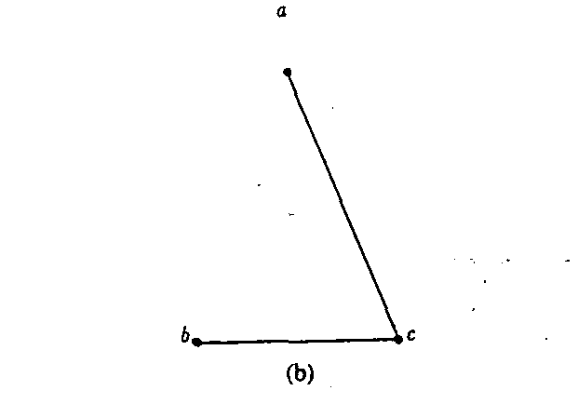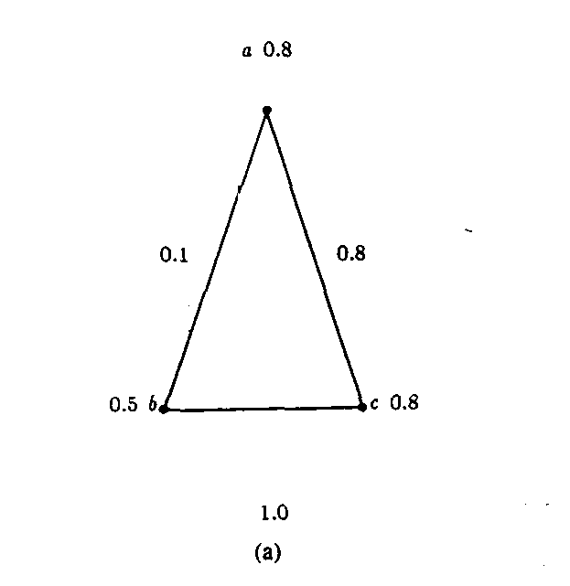
Heuristic I.
V_{a} = round(0.8(0.1+0.8))=1
V_{b} = round(0.5(0.1+1.0))=1
V_{c} = round(0.8(0.8+1.0))=1
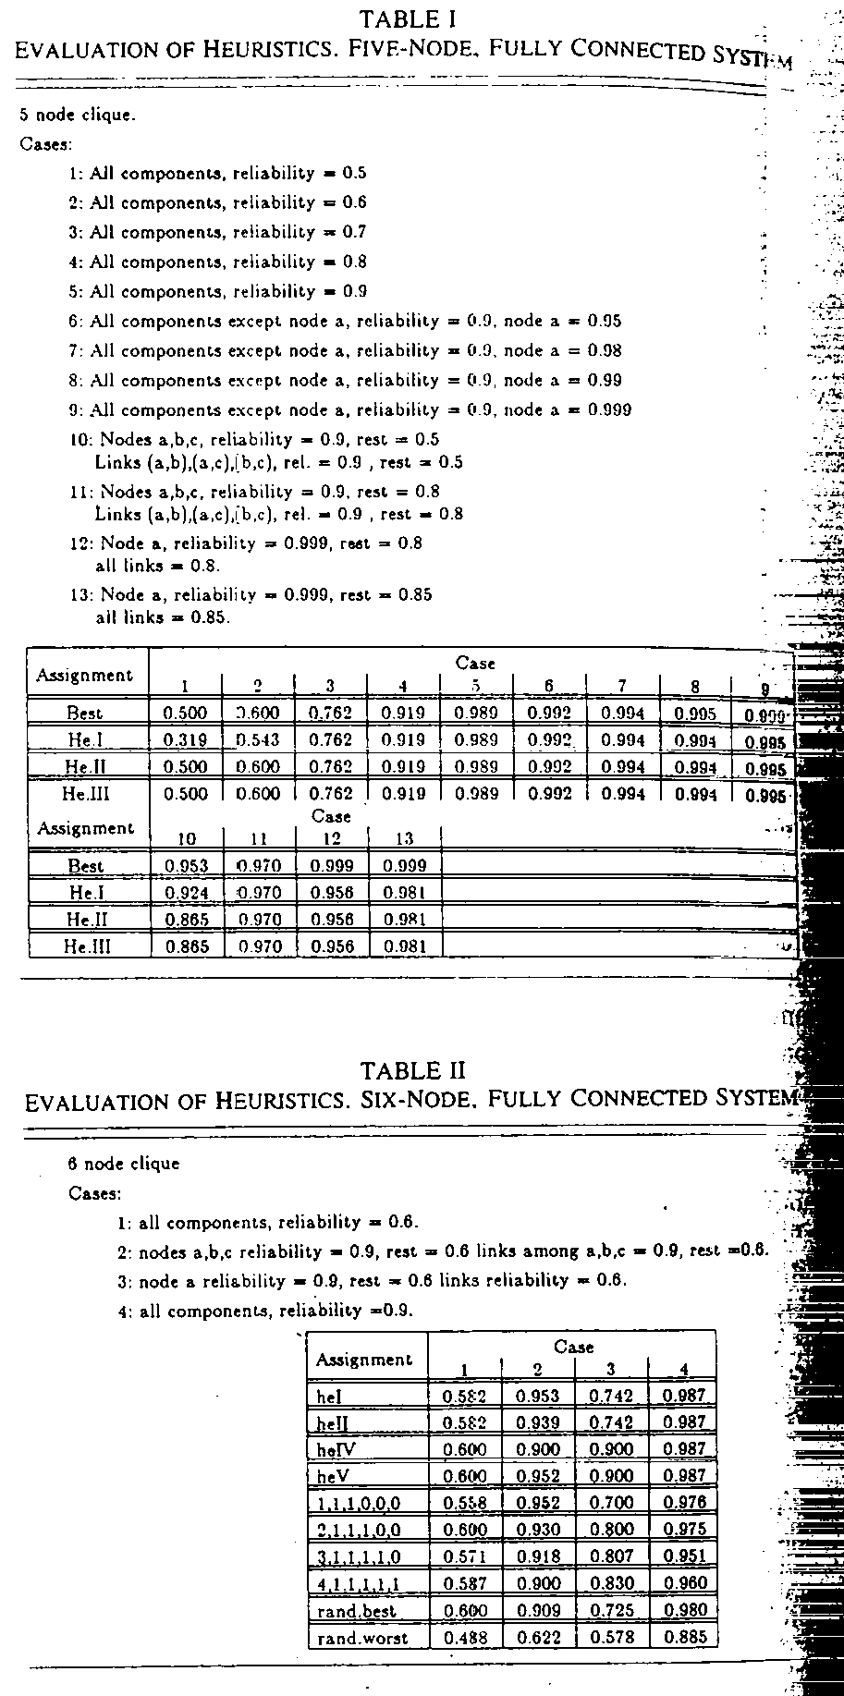
Heuristic II.
V_{a} = round(0.8(0.5*0.1+0.8*0.8))=1
V_{b} = round(0.5(0.1*0.8+1.0*0.8))=0
V_{c} = round(0.8(0.8*0.8+1.0*0.5))=1
Heuristic III.
<1,0,0> <0,1,0> <0,0,1>
Either the first or the third assignment result in a system reliability of P = 0.8.
Two of observations can be made at this point. First, the heuristics perform well. In almost all the cases we tested, at least one of the three heuristics was able to match the best assignment found.
(18 % not reach the best.)
(difference less than 5 %)

- Fully Connected, Homogenous Systems
For B with perfect links, if p is greater than 0.5, then the uniform assignment is better than any nonuniform assignment.

- Homogenous Ethernet Systems
For C with perfect links, if p is greater than 0.5, then the uniform assignment is better than any nonuniform assignment.

- Homogenous Rings
- Intermediate Graphs

- Conclusion
Created by : Kwo-Tsung Tseng
Date : Nov. 5, 1998

